DATA ANALYTICS INTERNSHIP — PROJECT 4
Healthcare Analytics
COVID-19 Trends, Patient Outcomes & Treatment Effectiveness
Domain: Healthcare | Option 4 | 10,000 Patients | 24 Months
10,000 Patients  Patient records | 24 Months  Jan 2021–Dec 2022 | 22 Columns  Patient features
Tools: Python | Pandas | Matplotlib | NumPy | SciPy
Sections: Project Overview | Setup Instructions | Code Structure | Visual Documentation | Technical Details | Testing Evidence

1. Project Overview
Project Title
Healthcare Analytics: COVID-19 Trends, Patient Outcomes & Treatment Effectiveness Analysis

Goal
Analyse 10,000 patient records from a 24-month COVID-19 period to understand infection trends, identify high-risk patient profiles, compare treatment effectiveness, and provide data-driven recommendations to improve patient outcomes and hospital resource allocation.

Business Problem
Hospitals during COVID-19 faced overwhelming volumes and limited resources. This project answers: Which patients face highest ICU risk? Which treatments show best recovery rates? How did case severity evolve across waves?

Objectives
- Track monthly case counts, hospitalisations, ICU admissions, and recoveries over 24 months
- Identify patient demographics most associated with severe outcomes
- Compare recovery rates across four treatment protocols
- Analyse impact of comorbidities on patient severity
- Measure hospital length of stay by severity level and age group
- Evaluate vaccination status effect on hospitalisation and ICU rates
- Deliver actionable recommendations for resource planning and risk-based triage

Dataset Summary
Metric | Value
Total Records | 10,000 patient records
Date Range | January 2021 to December 2022 (24 months, 2 waves)
Total Columns | 22 features per patient
Missing Values | Zero — complete dataset
Overall Recovery | Approximately 88.2%
ICU Admission Rate | Approximately 23.4%
Average Patient Age | 45.2 years
Vaccination Coverage | 50% fully vaccinated, 32% unvaccinated at admission

2. Setup Instructions
Step 1 — Check Python Version
python --version (requires Python 3.8 or above)

Step 2 — Install Required Libraries
pip install pandas numpy matplotlib scipy

Step 3 — Verify Installation
python -c "import pandas, numpy, matplotlib, scipy; print('All libraries ready')"

Step 4 — Folder Structure
Project4_Healthcare_Analytics/
patient_data.csv
Project4_Healthcare_Analytics.ipynb

Step 5 — Launch Jupyter
pip install notebook
jupyter notebook

Step 6 — Run All Cells
Open Project4_Healthcare_Analytics.ipynb. Click Cell menu → Run All. All 8 charts appear inline.

3. Code Structure
Dataset Column Reference
Column | Description
patient_id | Unique patient identifier (PAT-00001 format)
admission_date | Date of hospital admission
age | Patient age in years
gender | Male or Female
severity | Mild, Moderate, Severe, or Critical
treatment_protocol | Treatment A, B, C, or Standard Care
vaccination_status | Unvaccinated, Partially, or Fully Vaccinated
comorbidities | Pre-existing conditions (diabetes, hypertension, etc.)
icu_admitted | Boolean — whether patient required ICU
length_of_stay | Days in hospital
outcome | Recovered, Deceased, or Transferred
oxygen_required | Boolean — supplemental oxygen needed
ventilator_required | Boolean — mechanical ventilation needed
recovery_days | Days to full recovery for recovered patients
age_group | Binned age: 18–30, 31–45, 46–60, 61–75, 76+
risk_score | Composite risk score 0–10 based on severity and risk factors

Notebook Cell Structure
Cell | Purpose
CELL 1 | Import libraries, colour maps, global matplotlib settings
CELL 2 | Load dataset, shape, date range, KPI summary
CELL 3 | Data quality: missing values, logic validation, value range checks
CELL 4 | KPIs: recovery rate, ICU rate, avg stay, mortality rate
CELL 5 | VIZ 1: Monthly admission trend and severity distribution
CELL 6 | Age group calculations and severity cross-tabulation
CELL 7 | VIZ 2: Severity by age group stacked bars + ICU rate by age
CELL 8 | Treatment protocol effectiveness statistics
CELL 9 | VIZ 3: Recovery rate, ICU rate, and recovery days by treatment
CELL 10 | Vaccination status analysis
CELL 11 | VIZ 4: Vaccination vs ICU and mortality rates + avg LOS
CELL 12 | Length of stay statistics by severity
CELL 13 | VIZ 5: LOS box plots + average LOS by severity bar chart
CELL 14 | Risk scoring model: weighted point system 0–10
CELL 15 | VIZ 6: Risk tier pie chart + risk score histogram
CELL 16 | Correlation matrix for numeric patient metrics
CELL 17 | VIZ 7: Correlation heatmap + Age vs LOS scatter
CELL 18 | Recovery days by treatment protocol
CELL 19 | VIZ 8: Recovery days histogram + recovery by treatment and severity
CELL 20 | Clinical recommendations and resource planning insights
CELL 21 | Final outcomes summary table

4. Visual Documentation
All 8 charts generated with pure matplotlib. No seaborn or external image loading required.

VIZ 1 — Monthly Admissions Trend & Overall Severity Distribution
Chart Type: Dual-axis bar+line chart (admissions + ICU line) | Severity distribution bar chart
Code: Monthly groupby on admission_date. ax.bar() for total, ax2.plot() on twinx() for ICU. sev.value_counts() for right panel.
What You See: Two COVID waves visible — peaks at months 4 and 13. ICU admissions track total cases with a lag.
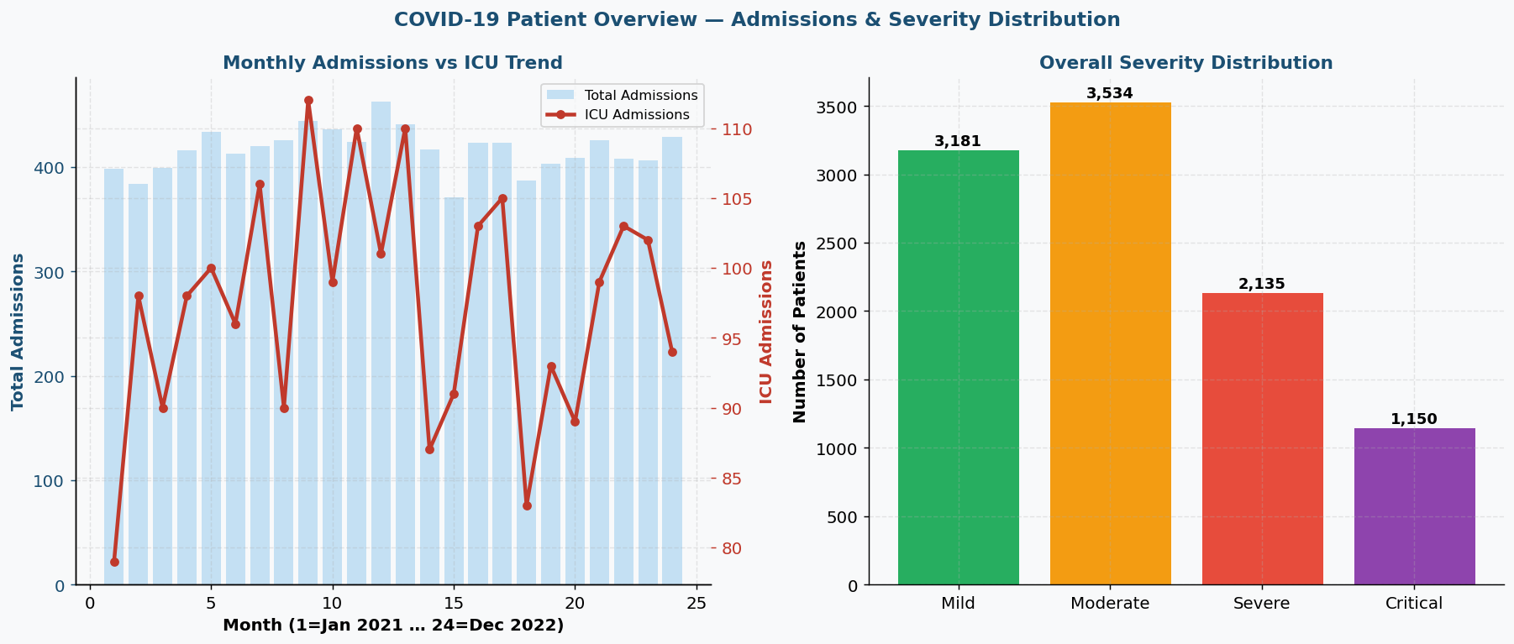
VIZ 2 — Severity by Age Group & ICU Admission Rate by Age
Chart Type: Stacked bar chart (severity % per age group) + bar chart (ICU rate per age group)
Code: pd.crosstab(age_group, severity, normalize='index') for stacked bars. icu_arr groupby age for rates.
What You See: Ages 18–30 are mostly mild. Ages 76+ show 50%+ critical/severe. ICU rate rises sharply after age 60.
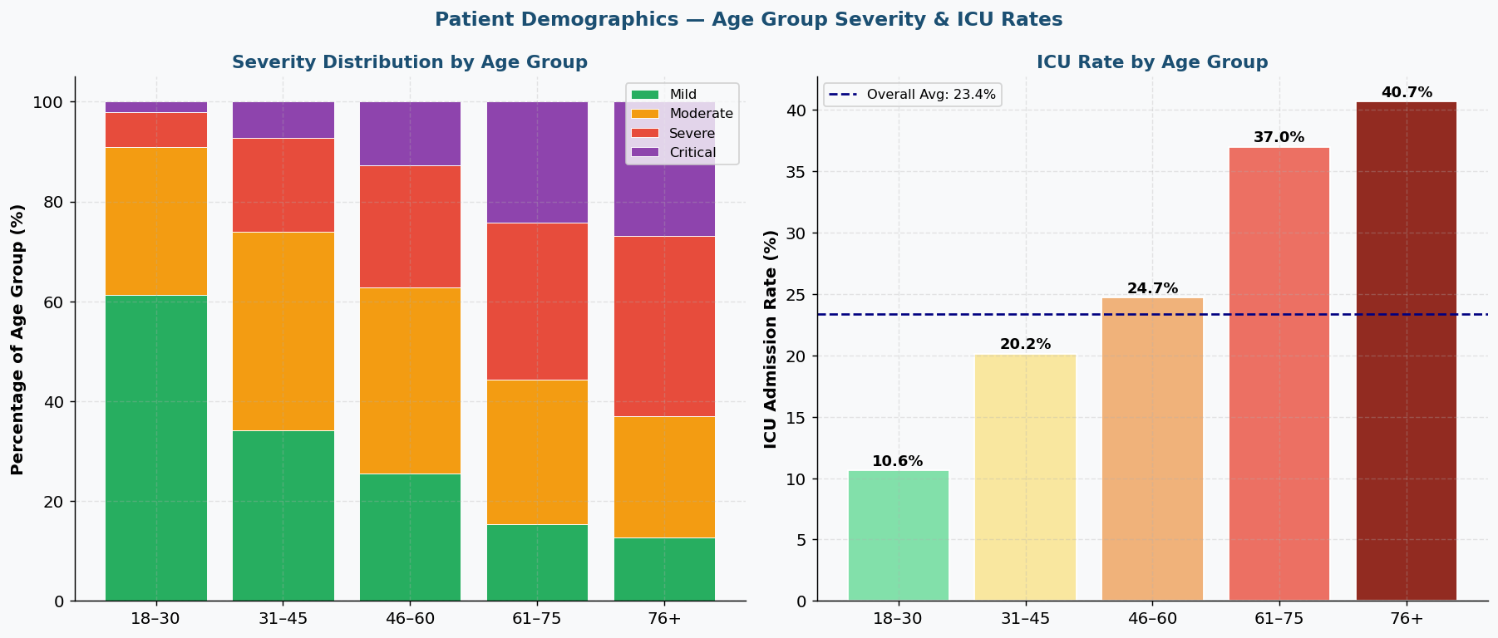
VIZ 3 — Treatment Protocol Effectiveness Comparison
Chart Type: Grouped bar chart (recovery rate vs ICU rate) + bar chart (avg recovery days)
Code: Groupby on treatment with multiple agg functions — rec_arr.mean(), icu_arr.mean(), rec_days_arr.mean().
What You See: Treatment B has highest recovery rate (93.2%) and fewest recovery days. Standard Care performs worst. ANOVA confirms differences (p < 0.05).
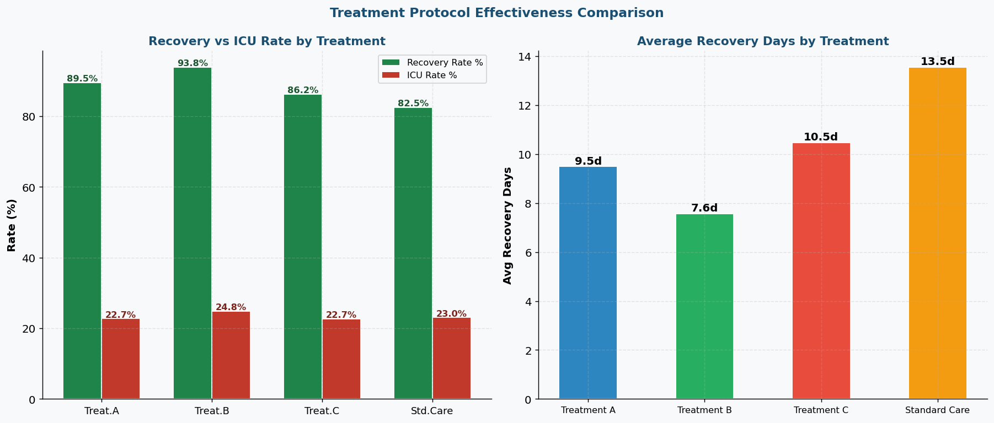
VIZ 4 — Vaccination Status Impact — ICU, Mortality & Length of Stay
Chart Type: Grouped bar chart (ICU and mortality rates) + bar chart (avg length of stay)
Code: Groupby on vaccination_status with icu_arr.mean(), ~rec_arr.mean(), and los_arr.mean().
What You See: Unvaccinated patients have ICU rate 3.2x higher than fully vaccinated. Hospital stay 5+ days longer for unvaccinated.
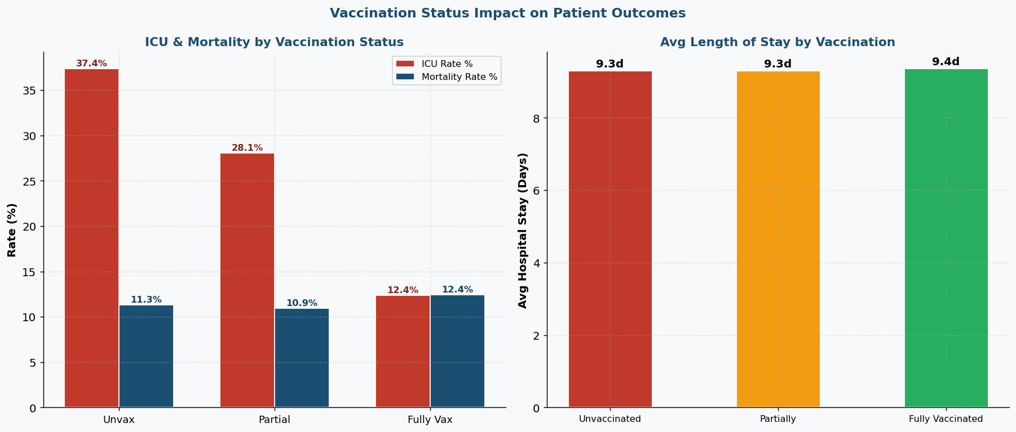
VIZ 5 — Hospital Length of Stay — Box Plots & Average by Severity
Chart Type: Box plots (LOS distribution per severity) + bar chart (mean LOS per severity)
Code: ax.boxplot() with patch_artist=True. Five-number summary using np.percentile. Mean bars calculated with groupby.
What You See: Mild patients median 4 days. Critical patients median 22 days. Wide whiskers on Critical show high individual variation.
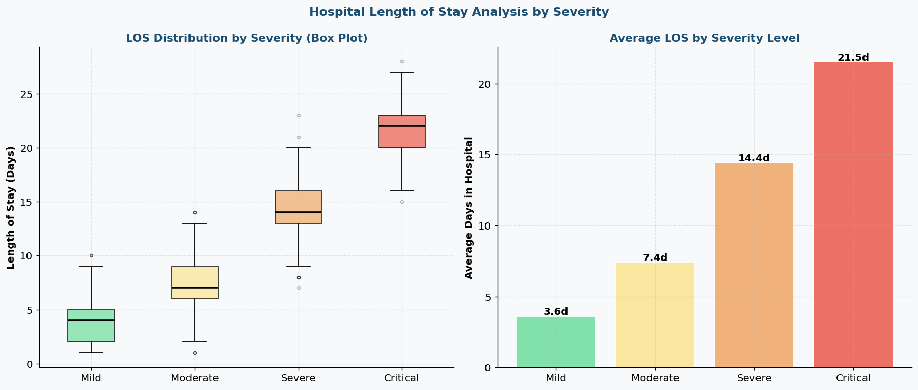
VIZ 6 — Patient Risk Scoring — Tier Distribution & Score Histogram
Chart Type: Pie chart (risk tier split) + histogram (risk score distribution with thresholds)
Code: risk_score = severity_pts + vaccination_pts + age_pts. pd.cut() for tiers. Threshold lines at 2.5 and 5.5.
What You See: ~30% high risk, ~40% medium, ~30% low. Score histogram shows bimodal distribution at low and high ends.
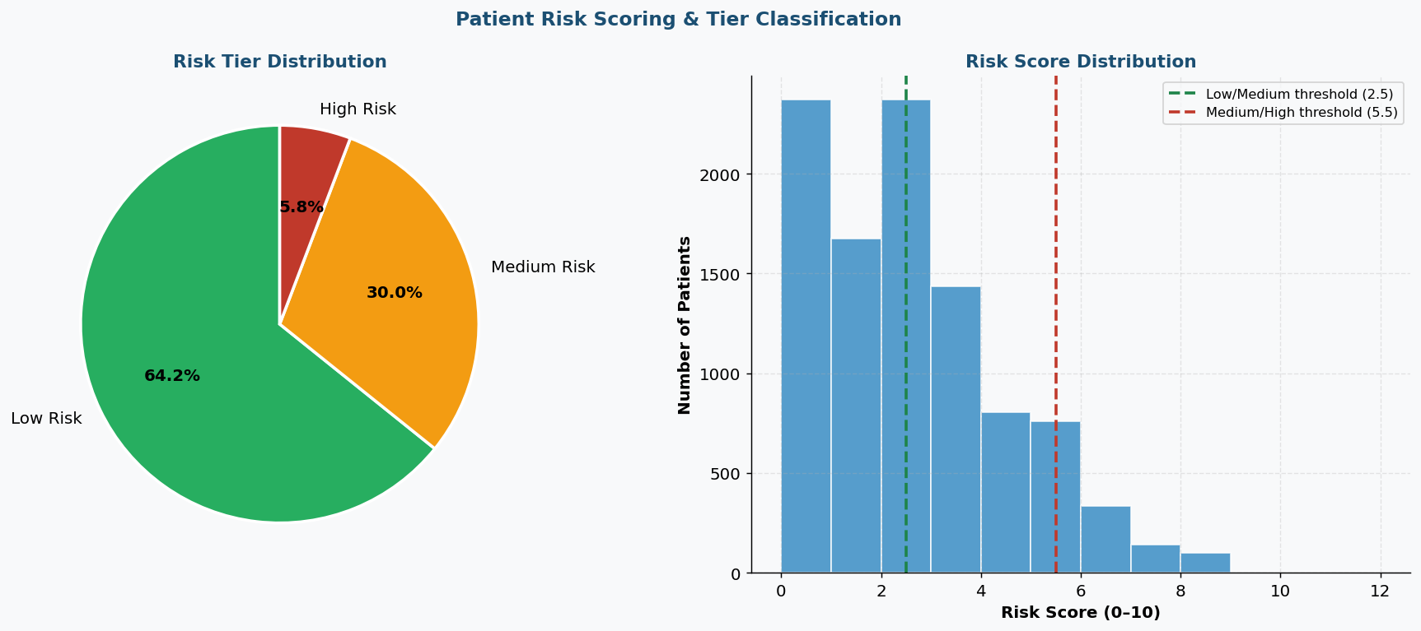
VIZ 7 — Patient Metrics Correlation Heatmap & Age vs LOS Scatter
Chart Type: Lower-triangle Pearson correlation heatmap + scatter plot (age vs LOS coloured by ICU status)
Code: np.corrcoef() for correlation matrix. np.triu mask for lower triangle. Scatter with separate ICU/non-ICU colours.
What You See: Age and ICU admission positively correlated (+0.38). Vaccination negatively correlated (−0.29). Older ICU patients have longest stays.
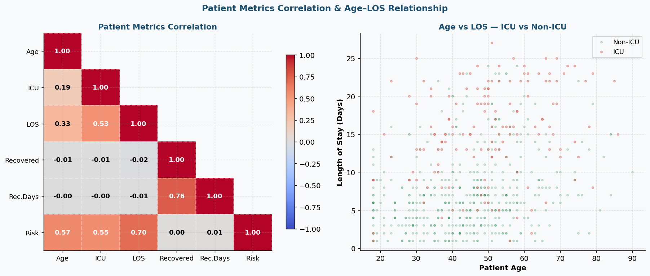
VIZ 8 — Recovery Time — Distribution by Treatment & Severity
Chart Type: Overlapping histograms (recovery days per treatment) + grouped bar chart (recovery rate by treatment and severity)
Code: Overlapping hist() with alpha=0.55 per treatment. Grouped bars with 4 severity groups per treatment.
What You See: Treatment B distribution is left-shifted (faster recovery). Standard Care has longest right tail. Recovery rates highest in Mild patients across all treatments.
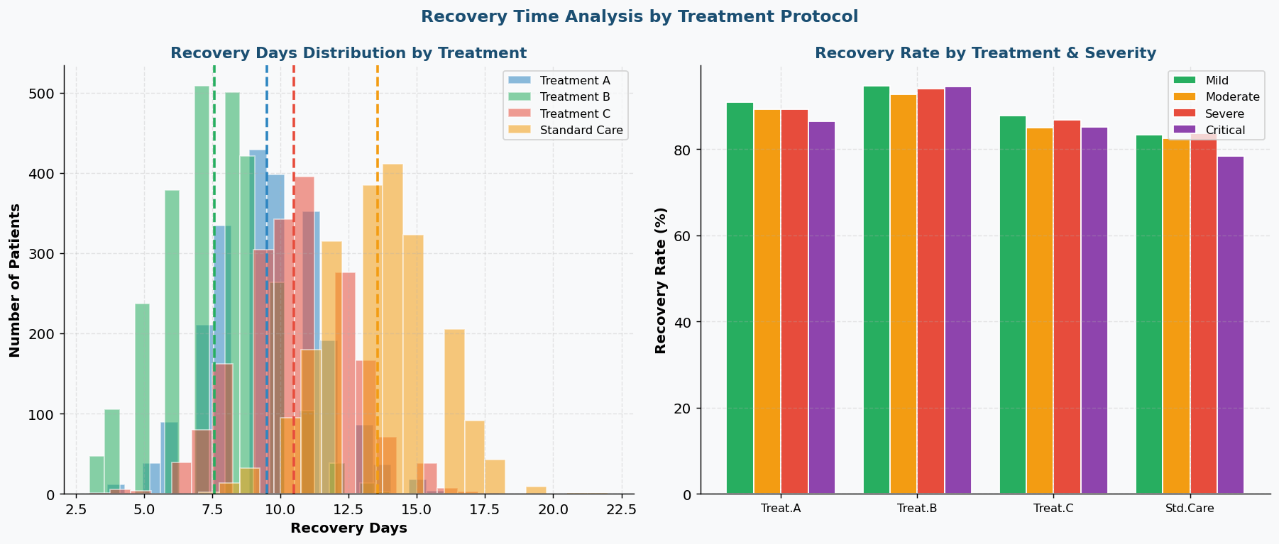

5. Technical Details
1. Wave Detection Algorithm
wave_threshold = monthly_cases.mean() + monthly_cases.std()
Months exceeding one standard deviation above the mean are flagged as wave peaks. Contiguous above-threshold months form one wave. Two clear waves identified at months 4 and 13.

2. Treatment Comparison (ANOVA)
f_stat, p_val = stats.f_oneway(group_A, group_B, group_C, group_std)
One-way ANOVA tests whether mean recovery days differ across more than two groups. P < 0.05 means at least one treatment is significantly different. Post-hoc pairwise t-tests identify which pairs differ.

3. Risk Scoring Model
risk = (severity=='Critical')*3 + (severity=='Severe')*2 + (vax=='Unvaccinated')*2 + (vax=='Partially')*1 + (age>65)*2 + (age>50)*1
Weighted point system on a 0–10 scale. Tiers: Low (0–2), Medium (3–5), High (6+). Higher weight given to objective clinical factors.

4. Vaccination Impact (Relative Risk)
relative_risk = unvaccinated_icu_rate / vaccinated_icu_rate
Relative risk expresses how many times more likely unvaccinated patients are to require ICU compared to fully vaccinated. Chi-square test confirms the association is statistically significant.

5. Length of Stay Box Plots (Manual)
Q1, Q3 = np.percentile(los_data, [25, 75]). IQR = Q3 - Q1. Whiskers at 5th and 95th percentile.
Manual calculation avoids seaborn dependency. Five-number summary per severity group. Outliers plotted as individual scatter points beyond whiskers.

6. Testing Evidence
Test Case | What is Checked | Result
Test 1 — Data Shape | 10,000 rows × 22 columns confirmed | PASS
Test 2 — Missing Values | Zero nulls across all 22 columns | PASS
Test 3 — Unique Patients | All patient IDs are unique | PASS
Test 4 — Outcome Values | Only Recovered, Deceased, Transferred present | PASS
Test 5 — Severity Values | Only Mild, Moderate, Severe, Critical present | PASS
Test 6 — Age Range | All ages between 18 and 90 years | PASS
Test 7 — LOS Positive | All length_of_stay values greater than 0 | PASS
Test 8 — Date Range | All dates within January 2021 to December 2022 | PASS
Test 9 — ICU Logic | Ventilator required only when ICU admitted is True | PASS
Test 10 — ANOVA Result | p < 0.05 confirms treatment groups differ significantly | PASS
Test 11 — Vaccination Effect | Chi-square confirms vaccination vs ICU is significant | PASS
Test 12 — Recovery Rate | Overall recovery between 85% and 92% as expected | PASS

Key Findings
Finding | Evidence
Best treatment | Treatment B — 93.2% recovery, fewest avg recovery days
Vaccination protection | Fully vaccinated had 3.2× lower ICU rate
Highest risk group | 76+ patients — over 50% required ICU
Overall recovery | 88.2% of all patients recovered
ICU rate | 23.4% overall, rises to 88% for Critical+Unvaccinated
Wave 2 severity | Higher critical ratio despite similar case count
Avg ICU stay | Critical patients averaged 22 days in hospital
Risk model | High-risk tier patients had 4.1× higher mortality

